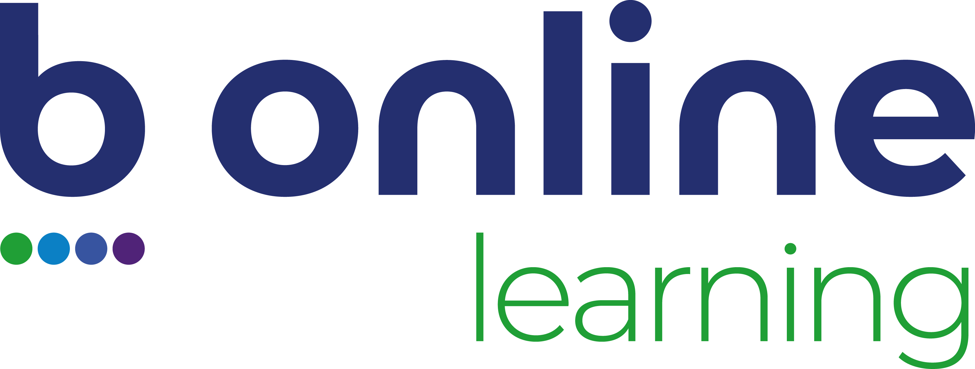
Replace image with your company logo

Building the Case for eLearning

This comprehensive template helps you create a persuasive, data-driven business case for implementing or expanding eLearning in your organisation. Use it to align learning initiatives with strategic objectives, quantify benefits, and address risks before presenting for approval.

1. Overview
Summarise the purpose, background, and scope of this business case. Include strategic alignment to organisational goals such as compliance, innovation, customer satisfaction, or workforce capability.
Example: This proposal outlines the implementation of an organisation-wide eLearning program to reduce training costs, improve consistency, and enhance learner engagement.
Stakeholders:
Project Sponsor:
Date:

2. The Problem
Describe the challenge or inefficiency in your current training approach. Include metrics where possible.
Examples:
• High facilitation or travel costs for classroom delivery.
• Inconsistent content delivery leading to audit failures.
• Staff unable to access learning remotely.
• Manual tracking and reporting processes.
Use the table below to summarise the current and desired states:
Current State | Desired Future State
Face to face sessions vary by facilitator and lack consistency. | Online modules ensure every learner receives the same key messages.
New hires rely on shadowing; onboarding quality depends on who trains them. | Structured eLearning ensures all new starters complete consistent, trackable induction.
Training materials live in shared drives and are often outdated. | A central LMS hosts version-controlled, up-to-date modules accessible anytime.
Compliance training requires manual sign-offs and spreadsheets. | Automated tracking and completion certificates save admin time and reduce errors.
Travel and facilitation costs limit how often refresher training can occur. | eLearning reduces travel costs and enables frequent, flexible refreshers.
Policies are shared as PDFs with little engagement. | Interactive Rise 360 modules transform policies into searchable, scenario-based content.
Learners forget content soon after workshops. | Microlearning reinforces key points with short, mobile-friendly follow-ups.
Limited visibility of learning progress across departments. | Birch dashboards and reports provide real-time data for managers and HR.
Inconsistent branding and design across courses. | Unified templates in Articulate ensure professional, on-brand learning experiences.
Difficulties reaching remote or shift-based staff. | Mobile-ready courses allow learners to complete training anywhere, anytime.
Technical content relies on lengthy manuals. | Short demonstration videos and animations make complex tasks easier to grasp.

3. The Impact
Quantify the financial, operational, and cultural impacts of the current challenge.
Example metrics: average cost per participant, training time per employee, compliance completion rates, error rates, or customer satisfaction scores.
Optional Impact Matrix:
Impact Area | Current Measure | Target Outcome | Potential Benefit
Compliance completion | 65% completion | 95% completion | Reduced risk of non-compliance fines

4. The Solution and Approach
Outline your proposed eLearning approach and how it will solve the identified challenges.
Include:
• Learning objectives and success measures
• Proposed tools and approach (Rise 360, Storyline 360, Birch LMS, animation)
• Target audience and accessibility considerations
• Integration with current systems or platforms
• Example structure for an Articulate Rise module (Introduction → Core Topics → Scenarios → Quiz → Resources)

5. Benefits and ROI
Demonstrate both tangible and intangible benefits using evidence or case studies.
- Example ROI formula: ROI = (Net Benefits / Total Costs) × 100
- Example calculation: Training cost reduction of $100,000 vs $30,000 development cost = 233% ROI.
Key benefits include:
• Reduced facilitation and travel costs
• Faster onboarding and higher productivity
• Consistent knowledge delivery
• Increased engagement and retention
• Improved compliance and audit readiness
• Continuous learning culture

6. Recommended Approach
Select the most appropriate delivery format for your training type.
Training Type | Best Format | Authoring Approach
Procedures & Policies | Modular eLearning | Rise 360
Soft Skills | Scenario-based Learning | Storyline 360
Product/System Demonstrations | Visual Learning | Animated Video or Screen Recording
Compliance | Short, Trackable Modules | Rise + Quiz Bank
Leadership & Culture | Blended Pathway | Storyline 360 + Virtual Facilitated Sessions

7. Example Scenarios
- Turning Policy PDFs into Dynamic Learning – Reduced training time by 60% with interactive Rise modules.
- Leadership Skills That Stick – Improved leader confidence by 40% through Storyline branching scenarios.
- Animated Safety Series – Lowered incident rates through engaging visual storytelling.
- Compliance Training Audits – Automated certificates and tracking simplified audit reporting.
- Onboarding for Hybrid Teams – Consistent induction experience across all locations.
- Data-Driven Conversations – Dashboards identified coaching needs and measured behaviour change.
- Customer Service Microlearning Boost – Improved NPS by 18% using 5-minute scenario videos.
- Technical Training Refreshers – Maintained certification compliance through quarterly Rise updates.

8. Implementation Plan
Outline the key stages, responsibilities, and timeframes for implementation. Here are some examples.
Phase | Key Activities | Timeline
Discovery | Define objectives, success measures, and key stakeholders. | Week 1
Design | Gather content, storyboard and visual design approval. | Weeks 2–3
Development | Build Rise/Storyline modules and integrate animations. Sync audio narration. Review cycles. | Weeks 4–6
Pilot | Test with sample users, gather feedback, refine content. | Week 7
Rollout | Deploy modules via LMS (e.g., Birch) and monitor engagement. | Week 8
Evaluation | Collect data on usage, feedback, and outcomes for ROI reporting. | Week 9+

9. Risk Analysis
Identify potential challenges and strategies to mitigate them. Assess each risk by likelihood and impact. Here are some examples.
Risk | Likelihood | Impact | Mitigation Strategy | Owner
SME availability | Medium | High | Pre-book SME reviews and use Articulate Review 360 for async feedback | Project Manager
Scope creep | Medium | Medium | Lock deliverables during storyboard sign-off | Instructional Designer
Technical limitations | Low | Medium | Early testing in LMS / Birch QA environment | Developer
Learner engagement | Medium | High | Use scenario-based learning and animation to maintain interest | Learning Designer
Accessibility compliance | Low | High | Apply WCAG AA standards and test with screen readers | QA Specialist
Change fatigue | Medium | Medium | Include change communications and a champion network | Client Lead
Summary: Risks can be effectively managed through proactive planning, clear communication, and iterative review cycles.

10. Next Steps
Summarise immediate actions to progress this business case.
Examples:
• Schedule scoping session
• Confirm stakeholders and timelines
• Approve budget estimate
• Meet with vendors
• Prepare EOI
Approval Table:
Name | Role | Signature / Date

Need help with your Business Case? Contact B Online Learning

